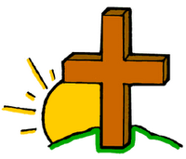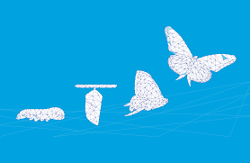

**OUR BIG QUESTION**

How and why do things change?

**REFLECTION**

Lord, when I am hungry give me someone to feed;

When I am thirsty give water for their thirst.

When a burden weighs upon me lay upon my shoulders the burden of my fellows.

Lord, when I stand greatly in need of tenderness, give me someone who yearns for love. May your will be my bread;

Your grace my strength; Your love my resting place.

**KEY VOCABULARY**

**change seasons spring growth Lent Ash Wednesday Good Friday Easter Sunday Alleluia Cross Resurrection**

**SCRIPTURE**

Joel 2:13

Luke 23: 33-35, 38-43

Mark 11: 1-11

Mark 16: 1-6

**CHANGE**

Year 1 Topic 6

Change is a necessary part of healthy growth.

This is a time to prepare for Easter.

Lent offers a time to reflect on life and change.