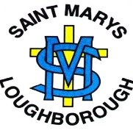
St Mary’s Catholic Primary School
Subject: Science | Year Group: 1 Term: Advent 1 | Title: Penguins, Possums and Pigs

What should I know?  - The features of living things and how they grow and change  - How to care for and show concern for living things  - How living things can have similarities and differences  - That patterns can be found when studying living things | 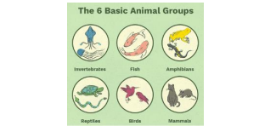  Facts I will learn…  - The different species of animals  - Whether animals are carnivores, herbivores or omnivores  - The features and structure of common animals  - Similarities and differences between common animals | Key Questions…  - How do we know they are animals?  - What makes an animal an animal? What features does it have?  - What things are similar between two different animals  - All animals are the same. True or False?  - How do animals move?  - What if animals couldn’t move around?
Key Skills…  - Identifying animals and their features  - Grouping and classifying animals according to their features, habitats and eating habits  - Comparing and contrasting at first hand or via photos  - Labelling pictures correctly.  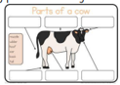 | Experiences that school will provide:  - Observations of animals through real life and video. | Key Vocabulary and Definition:  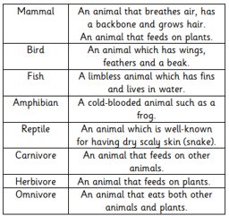
Web Links
https://www.bbc.co.uk/bitesize/subjects (Animal area)

https://www.everyschool.co.uk/science-key-stage-1-animals.html

