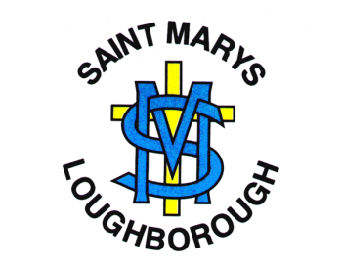
English Long Term Plan 2020-2021
 | Advent 1 | Advent 2 | Lent 1 | Lent 2 | Pentecost 1 | Pentecost 2
EYFS | All about Me | Traditional Tales | Past and Present | It’s Alive | Different Environments | Under the Sea
Year 1 | The Lost Kiwi  Fiction: Say and write simple sentences.  Poetry: Rhymes. Singular & Plural. | Poetry: Diwali festival. Bonfire night.  Four-line poem.  Non-Fiction: To ask and write questions.  To write information.  Fiction: Write sentences that can be read by themselves and others. | Fiction: Write about characters and settings.  Non-Fiction: Instructions.  Poetry: Pat a Cake. Hot Cross Buns. | Fiction: A range of Traditional Tales. Use connectives to link ideas.  Non-Fiction: Write a family recount. | Fiction: To write an opening, middle and end of a story  Poetry: Perform traditional rhymes.  Non-Fiction: Information Booklet | Fiction: To write a story about a robot.  Non Fiction: Write about how to make a robot.  Poetry: I'm a Little Robot
Year 2 | Stories with familiar settings  Non-chronological reports  Poems on a theme | Traditional tales with a twist  Instructions | Stories by the same author  Non-chronological reports | Stories with familiar settings  Persuasion  Persuasion  Riddles | Riddles  Animal adventure stories  Recount: Letters  Classic Poems | Story as a Theme  Explanations  Poems on a Theme
Year 3 | Folk Tales  Recount - Biography | Recount – Biography  Poems with a structure  Persuasive Letter | Narrative based on a theme  Poems on a theme  Discussion | Story based on plot from Iron Man  Recount - diaries | Playscripts  Non-chronological reports  Classic poetry | Mystery, adventure or fantasy story  Explanation
Year 4 | Explanations  Stories with fantasy settings  Film and playscripts | Fairy tales  Classic poetry  Recount: newspapers | Stories with issues and dilemmas  Persuasion | Novel as a theme  Non-chronological reports | Stories with a theme  Poems with a structure Information booklets | Folk tales  Debate
Year 5 | Narrative writing: Legends of the British Isles:  Persuasive writing | Stories with historical settings  Film and Playscripts  Classic Narrative | Science fiction story writing  Non-chronological report – information booklet  Poetry: Haikus and Limericks | Novel as a Theme  Non-fiction writing: Magazine information | Stories from other cultures  Persuasive writing: Debate  Myths | Reports – online resources  Poetry: Poems with figurative language
Year 6 | Narrative – Adventure Stories  Biography  Poetry: Odes | Narrative workshop: Classic Fiction  Persuasion  Discussion | Older literature  Information text hybrid  Poems with imagery | Detective / crime fiction  Explanations | Narrative: Short stories with flashbacks  SATs preparation  SATs Week  Classic narrative poetry  Discussion and debate | Novel as a theme  Recount: autobiography  Poems on a theme

