**Science: Earth and Space**

Describe the movement of the Earth, and other planets, relative to the Sun in the solar system.

Describe the movement of the Moon relative to the Earth.

Describe the Sun, Earth and Moon as approximately spherical bodies.

Use the idea of the Earth’s rotation to explain day and night.

How are shadows made?

**Key words:**

**Sphere**: a round, solid figure with every point on its surface equidistant from its centre

**Revolve**: to move in a circle on a central axis

**Orbit:** a regular, repeating path that an object in space takes around another one

**Rotate**: to turn on its axis

**Axis**: an imaginary line about which a body rotates

**Solar System**: the **system** of the Sun and the objects that orbit it,

**Art and Design: Abstract Art**: Design an abstract landscape after exploring the work of Jackson Pollock, Wassily Kandinsky, Joan Miro, Kazimir Malevich and Mark Rothko

**Explore composition and different media (if possible):** paint, felt-tip, pencil crayons and pencil drawings or chalk

**Key words:**

**Composition**: the different parts which make up the whole picture

**Media**: the different types of materials you can use to paint and draw

**Abstract**: not a visual representation of reality

**English**

**Science-Fiction Stories**: The Fun They Had by Isaac Asimov and George’s Secret Key to the Universe by Stephen and Lucy Hawking

**Information booklets: non-fiction writing**. Children will write a non-chronological report and a set of instructions: Early thoughts: How to survive Zoom/Remote Learning. How to home school your children/parents. Other ideas welcome!

**Poetry**: write your own poem based on a favourite poem. We’ll find funny ones and then you can write your own about on-line learning and the funny things we do.

Greetings Earthlings! Saint Martin de Porres Knowledge Organiser Lent term 1

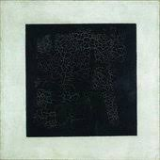

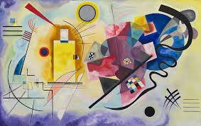

**Music**

Perform, listen to and recognise musical instruments and their tempo and timbre

**Tempo**: the speed at which music is played

**Timbre**: the character or quality of a sound

**Rhythm**: a pattern of movement or sound

**Melody**: a sequence of single notes that make a tune

**Pitch**: the quality of a sound – high or low tones

**R.H.S.E.**

**Module One: Created and Loved by God** explores the individual. Rooted in the teaching that **we are made in the image and likeness of God**, it helps children to develop an understanding of the importance of valuing themselves as the basis for personal relationships:

**Unit 1 – Religious Understanding**explores the Gospel story of the ‘Calming of the Storm’ (from Matthew, Mark and Luke). Over five story sessions, children will consider experiences of change, growth and development

**Unit 2 – Me, My Body, My Health**, children will learn that celebrating differences between people is enriching to a community and know that their self-confidence should arise from being loved by God. They will learn about the physical changes that boys and girls go through during puberty and how they should respect and take care of their bodies as gifts from God. Genitals are also mentioned here, but not named and identified.

**French**

**Cultural understanding**: La Fête des Rois: La Galette song

La famille: naming members of the family and saying their names and ages

Saying your Birthday and numbers to 50

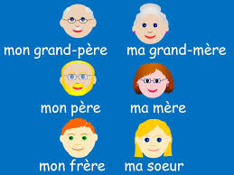

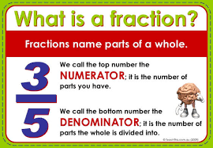

**Maths**

* Finish Area and Perimeter from Advent 2
* Multiplication and division
* Fractions: understand equivalent fractions
* Convert improper fractions to mixed numbers and vice versa
* Compare and order fractions less than and greater than 1
* Add, subtract and multiply fractions, inclusing mixed numbers
* Find fractions of an amount

**R.E.**

**Local Church - Community: Mission**

What is your mission in life?

Exploring mission, beginning with pupils’ own and the beginning of Jesus’ ministry. The organisation of our parish and diocese.

**Eucharist – Relating: Memorial Sacrifice**

Why do we need memories?

**Lent – Easter: Sacrifice**

What do we need to make sacrifices?