**Science: Material Properties**

**Reversible and irreversible changes**: Irreversible changes can't be undone, however, a reversible change means that the **original substance can be retrieved.**

**Saturate**: A solution in which **no more solute can be dissolved at any fixed temperature** is called a saturated solution.

**A solution:** a mixture of two or more substances

**Dissolving**: to cause a substance to disappear

**Melting**: to be changed from a solid to a liquid state

**Evaporating**: to turn from liquid to vapour

**Soluble and insoluble**: capable or incapable of being dissolved into a liquid

**Sieving**: to examine in detail or remove something

Food, Glorious Food! Saint Martin de Porres Knowledge Organiser Advent term 2

**Principles of Design Technology**: Designing a food product for KS2

**User**: who is it for? Who is your target user? Will it meet users’ needs?

**Purpose**: what will it be used for? Will it fulfil this purpose? Is it practical and aesthetic?

**Functionality**: will it fulfil needs, wants and purposes of the user? Will it work?

**Design decisions**: be creative, technical and practical.

**Innovation**: be creative, be a problem solver: is your design original?

**Authenticity**: is it believable, real and meaningful?

**English**

Stories with historical settings: Oliver Twist and The Lion, the Witch and the Wardrobe: write a new chapter

Films and playscripts: write your own scene! Based on the film, “Oliver”

Poetry: write and perform your own poetry

* JRR Tolkien: Chip the glasses and crack the plates, (taken from The Hobbit)
* Timothy Winters by Charles Causley.
* A Visit from St Nicholas by Clement Clarke Moore.

**Geography**

**Export and import:** exporting is when a product is produced in Britain and sold to foreign countries. Importing is when Britain buys products from abroad.

**Fair trade:** trade between companies in developed countries and producers in developing countries in which fair prices are paid to the producers.

**Air miles:** how far food has to be flown to get to where it I being sold

**Climate:** the weather condition in a country on the whole

**Lines of latitude and longitude:** imaginary lines to help locate where a place is in the world

**Tropics of Cancer and Capricorn:** the latitudes of the earth, north and south of the equator

**Equator**

**Northern and Southern hemisphere**

**Maths**

* Addition and subtraction, multiplication and division
* Inverse operations
* Interpret charts, line graphs, timetables
* Factors, prime, cube and square numbers
* Properties of shape: find the perimeter and area of

compound and irregular shapes

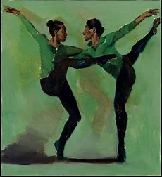

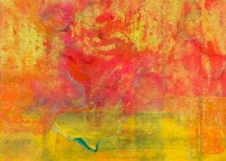

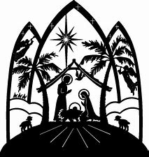

**French**: greetings, name, age, numbers to 30, days of the week and months of the year, saying your birthday, talking about Christmas

**Art and Design**

**Atmosphere**: the tone or mood

**Wet, dry, mixed media**: paint, pencil, charcoal or a mixture of both

**Tonal study**: how light or dark something is

**Preliminary study**: an initial exploration of ideas

**JWM Turner:** 18th Century landscape artist

**Frank Bowling:** 20th century black British artist

**Lynette Yiadom-Boakye:** 20th century black British artist [Tate Kids](https://www.tate.org.uk/kids)

Tate

**R.E.**

**Other Faiths: Judaism**: exploring the story of the Exodus and symbolism of the Seder plate

**Advent: Christmas: Loving: Hope**

Exploring Isaiah, the story of the Nativity and how the prophets foretold the coming of the Messiah.

What it means to wait hopefully, based on our own experience of waiting and the example of Our Lady

