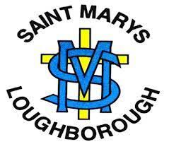

Draft summary of RSHE policy for Saint Mary’s Catholic Primary School
Mission Statement

With Jesus as our guide, we promise
To care for one another
To work hard
To build a community in Christ’s love

Rationale

‘I HAVE COME THAT YOU MIGHT HAVE LIFE AND HAVE IT TO THE FULL’ (Jn.10.10)

We are involved in relationships and sex education because of our Christian beliefs about God and about the human person. The belief in the dignity of the human person made in the image and likeness of God is the foundation of all education in a Catholic school. Our approach to RSE therefore is rooted in the Catholic Church’s teaching of the human person and presented in a positive framework of Christian ideals.
RSE is centred on Christ’s vision of being human as good news and will be positive and prudent, showing the potential for development, while enabling the dangers and risks involved to be understood and appreciated.
All RSE will be taught in agreement with the Church’s teaching. It will emphasise the central importance of marriage and the family whilst acknowledging that all pupils have a fundamental right to have their life respected whatever household they come from. It will also prepare pupils for life in modern Britain.
AIM OF RSE AND THE MISSION STATEMENT
Our Mission Statement commits us to the education of the whole child (spiritual, physical, intellectual, moral, social, cultural, emotional) and we believe that RSE is an integral part of this education. Furthermore, our school aims state that we will strive to raise pupils’ self-esteem, help them to grow in knowledge and understanding, recognise the value of all persons and develop caring and sensitive attitudes. It is in this context that we commit:
In partnership with parents, to provide children and young people with a “positive and prudent sexual education” (Gravissimum Educationis 1 ) which is compatible with their physical, cognitive, psychological, and spiritual maturity, and rooted and rooted in a Catholic vision of education and the human person.
Objectives
To develop the following attitudes and virtues:
- reverence for the gift of human sexuality and fertility;
- respect for the dignity of every human being – in their own person and in the person of others;
- joy in the goodness of the created world and their own bodily natures;
- responsibility for their own actions and a recognition of the impact of these on others;
- celebrating the gift of life-long, self-giving love;
- recognising the importance of marriage and family life;

To develop the following personal and social skills:
- making sound judgements and good choices which have integrity, and which are respectful of the individual’s commitments;
- loving and being loved, and the ability to form friendships and loving, stable relationships free from exploitation, abuse and bullying;
- managing conflict positively, recognising the value of difference;
- cultivating humility, mercy and compassion, learning to forgive and be forgiven;
- developing self-esteem and confidence, demonstrating self-respect and empathy for others;
- building resilience and the ability to resist unwanted pressures, recognising the influence and impact of the media, internet and peer groups and so developing the ability to assess pressures and respond appropriately;
- assessing risks and managing behaviours in order to minimise the risk to health and personal integrity.

To know and understand:
- the Church’s teaching on relationships and the nature and meaning of sexual love;
- the Church’s teaching on marriage and the importance of marriage and family life;
- the centrality and importance of virtue in guiding human living and loving;
- the physical and psychological changes that accompany puberty;
- the facts about human reproduction, how love is expressed sexually and how sexual love plays an essential and sacred role in procreation;

Outcomes

INCLUSION AND DIFFERENTIATED LEARNING

We will ensure RSE is sensitive to the different needs of individual pupils in respect to pupils’ different abilities, levels of maturity and personal circumstances; for example, their own faith or culture and is taught in a way that does not subject pupils to discrimination. Lessons will also help children to realise the nature and consequences of discrimination, teasing, bullying and aggressive behaviours (including cyber-bullying), use of prejudice-based language and how to respond and ask for help. (In looking at these questions, it is important to draw links to the school’s inclusion policy).

EQUALITIES OBLIGATIONS

The governing body and school community have wider responsibilities under the Equalities Act 2010 and will ensure our school strives to do the best for all pupils, irrespective of disability, educational needs, race, nationality, ethnic or national origin, sex, religion or whether they are looked-after children.

BROAD CONTENT OF RSE
Three aspects of RSE - attitudes and values, knowledge and understanding, and personal and social skills will be provided in three inter-related ways: the whole school / ethos dimension; a cross-curricular dimension and a specific relationships and sex curriculum.

At Saint Mary’s we have decided to adopt Life to the Full by Ten Ten Resources. Ten Ten is an award-winning Catholic educational organisation that is well-respected and very experienced in this field of work. Life to the Full has been cited by the Department for Education as an example of good practice and is the only programme of study for RSHE from 3 – 18 years.

Ten Ten understands the important role parents have in educating their children and so, provides a parent portal and web page with resources and information for parents to access and stay informed.

Online Parent Portal
As part of your subscription to “Life to the Full”, all parents will be able to access the Online Parent Portal with the following login credentials:
Username | st-marys-le11
Password | purple-rose
Parent Portal URL | www.tentenresources.co.uk/parent-portal

The Ten:Ten programme is based on the model programme of study from the Catholic Education Service, divided in to three core themes:

- Created and loved by God. (We should love ourselves because we are made in the image of God.)
- Created to love others. (Love is the basis of all Christian morality – we are created out of love and for love.)
- Created to live in community. (We live within a community and are social beings. Through relationships with others, we can work for the kingdom of God, for the good of individuals and of society.)

Within each core theme there are three strands:

- Education in virtue
- Religious understanding
- RSHE content and subject matter

The programme will be delivered in a sequence of weekly lessons beginning during the spring and summer terms 2021

Overview of the programme of study
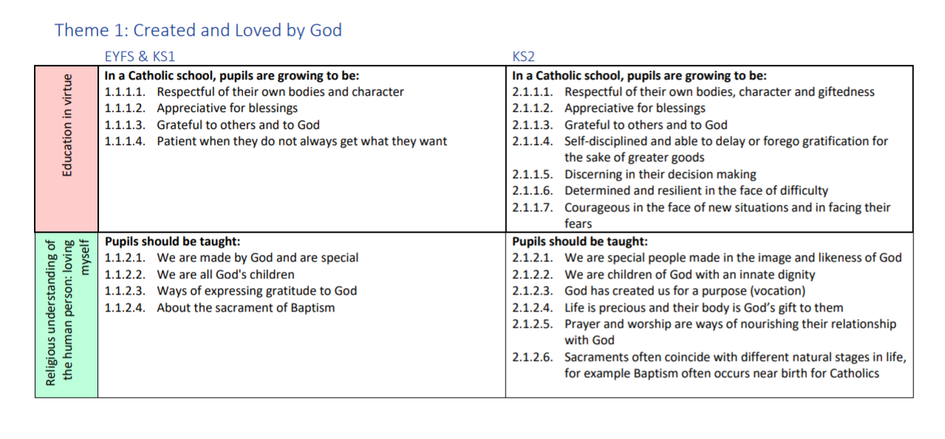

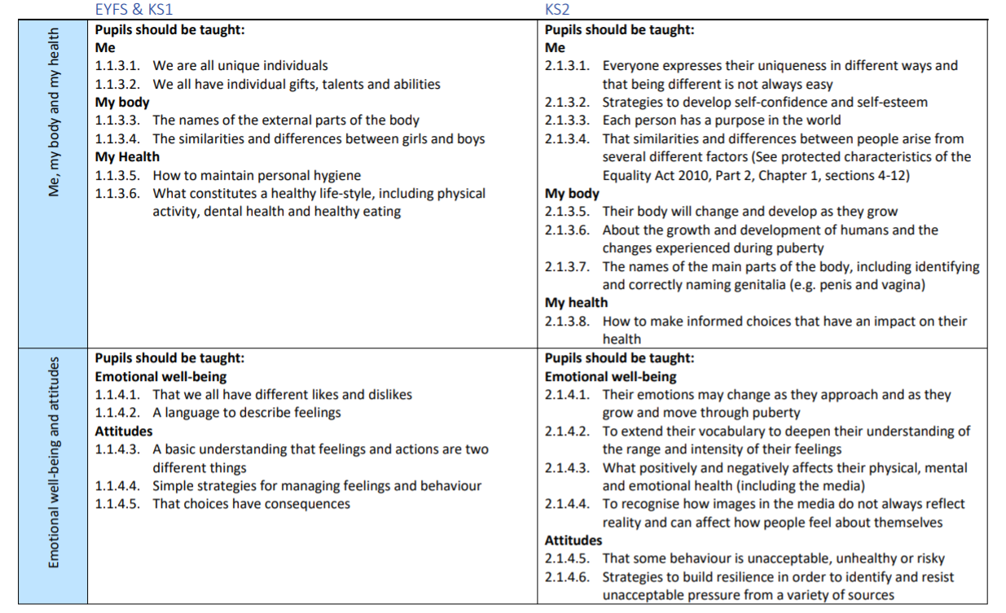

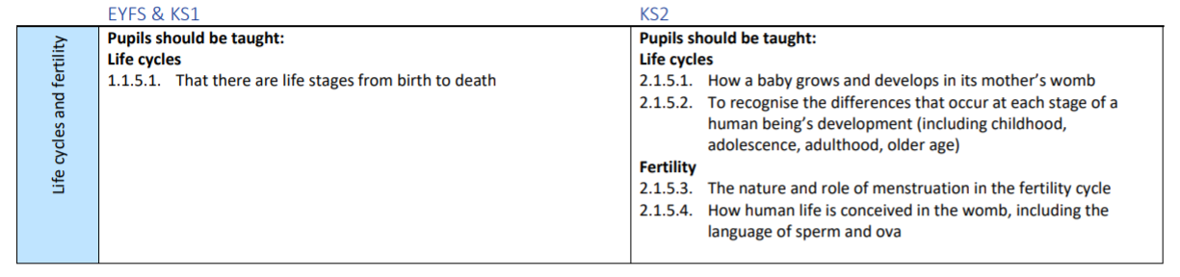

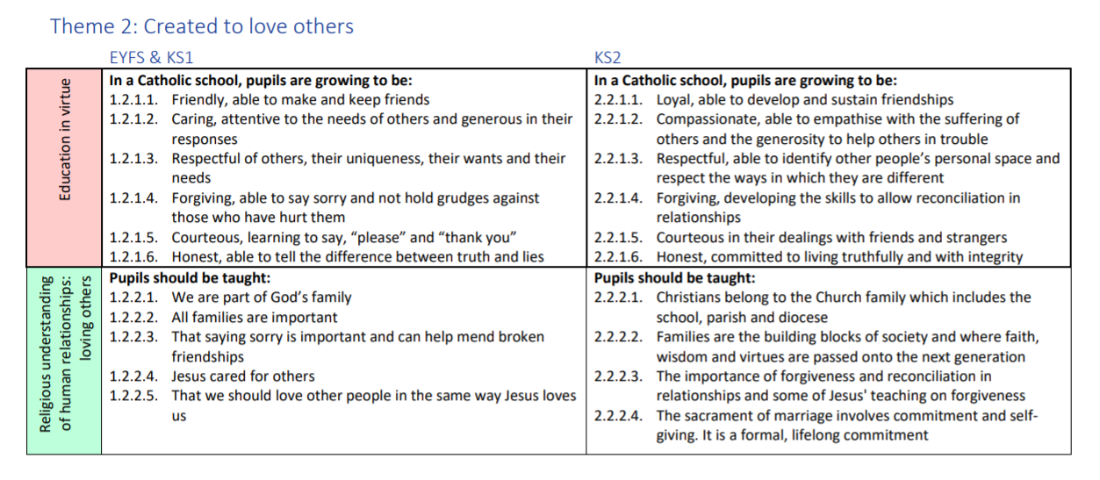

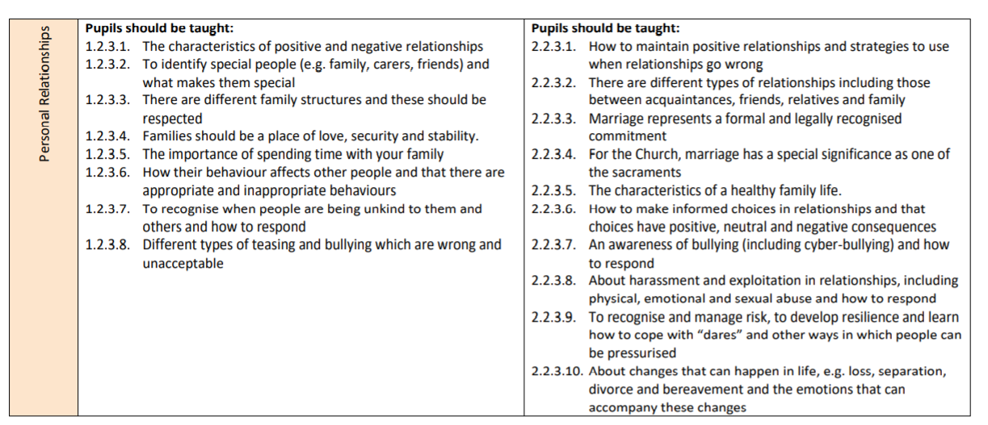

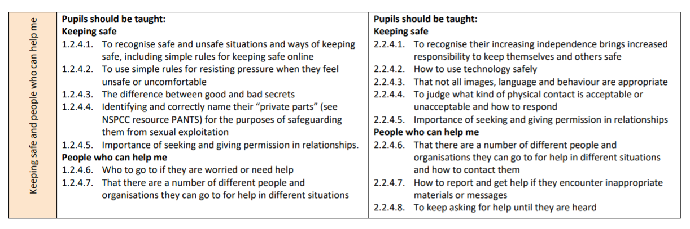

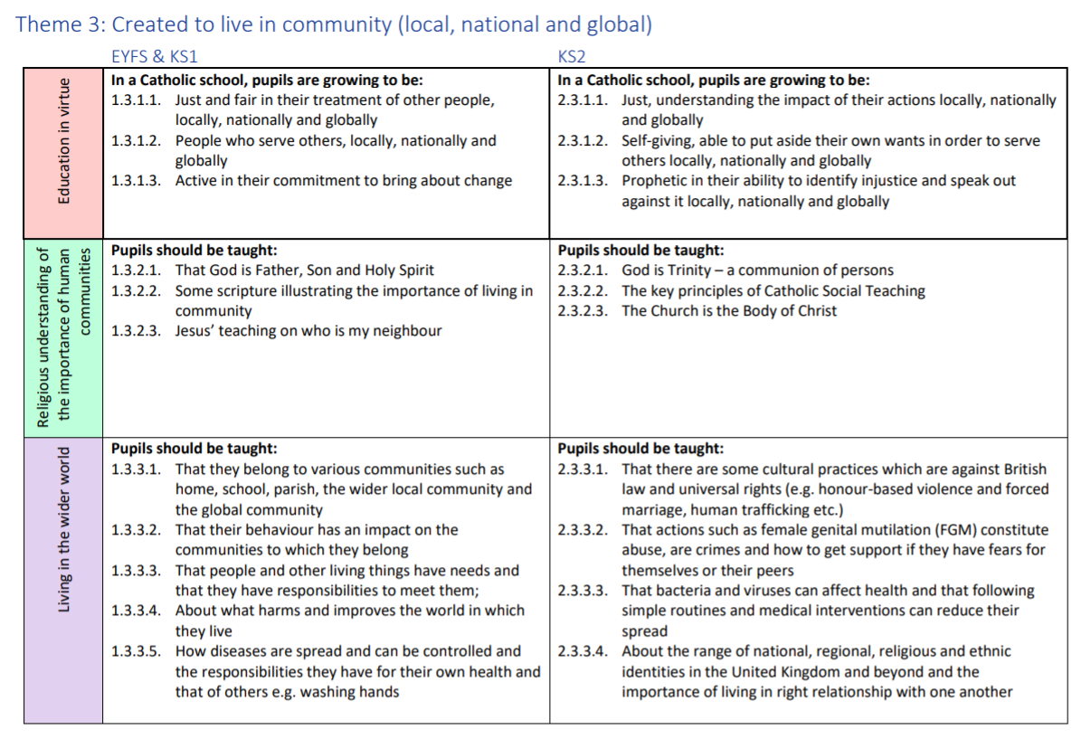

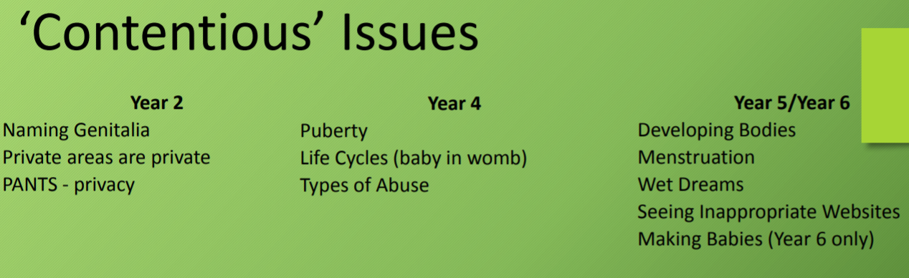

The DfE statutory guidance, the CES model policy, an overview of Journey in Love and A Fertile Heart can be found on the RSHE curriculum page of the school website.

RSHE must fulfil all the requirements of outstanding pedagogy and be:

- Progressive and developmental
- Differentiated
- Cross-curricular
- Integrated
- Coordinated
- Balanced

This will be achieved through:

- establishing ground rules distancing techniques
- discussion
- project learning
- reflection
- experiential
- active
- brainstorming
- film & video
- group work
- role-play
- trigger drawings
- values clarification

Assessment will take place against the requirements and objectives of the programme of study through quality of pupils’ written and verbal responses, actions and reflective pieces.

PARENTS AND CARERS

We recognise that parents and carers, are the primary educators of their children. The school will support parents and carers by providing material to be shared with their children at home and virtual online resources to help parents/carers to find out more. Parents and carers will be informed by letter when the more sensitive aspects of RSE will be covered in order that they can be prepared to talk and answer questions about their children’s learning.

Parents must be consulted before this policy is ratified by the governors. They will be consulted at every stage of the development of the RSE programme, as well as during the process of monitoring, review and evaluation. They will be able to view the resources used by the school in the RSE programme. Our aim is that, at the end of the consultation process, every parent and carer will have full confidence in the school’s RSE programme to meet their child’s needs.

Parents continue to have the right to withdraw their children from Sex Education except in those elements which are required by the National Curriculum science orders. Should parents wish to withdraw their children they are asked to notify the school by contacting the headteacher. The school will provide support by providing material for parents to help the children with their learning.

We believe that the controlled environment of the classroom is the safest place for this curriculum to be followed. Please refer to the DfE guidance Page 17 for further details on the right to be excused from sex education (commonly referred to as the right to withdraw).

BALANCED CURRICULUM

Whilst promoting Catholic values and virtues and teaching in accordance with Church teaching, we will ensure that pupils are offered a balanced programme by providing an RSE programme that offers a range of viewpoints on issues.

Pupils will also receive clear scientific information as well as covering the aspects of the law pertaining to RSE (in secondary schools/academies relating to forced-marriage, female genital mutilation, abortion, the age of consent and legislation relating to equality). Knowing about facts and enabling young people to explore differing viewpoints is not the same as promoting behaviour and is not incompatible with our school’s promotion of Catholic teaching. We will ensure that pupils have access to the learning they need to stay safe, healthy and understand their rights as individuals.

RESPONSIBILITY FOR TEACHING THE PROGRAMME

Responsibility for the specific relationships and sex education programme lays with the individual class teacher, (this will normally include science, religious education, physical education, RSE and PSHE).

However, all staff will be involved in developing the attitudes and values aspect of the RSE programme. They will be role models for pupils of good, healthy, wholesome relationships as between staff, other adults and pupils. They will also be contributing to the development of pupils’ personal and social skills.

