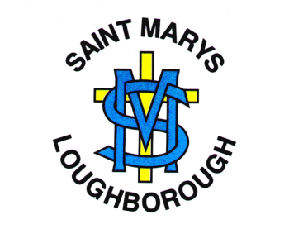
Phonics Long Term Plan
A guide as to when each phase is to be taught in Key Stage One (and Y3). Lessons during each term reflect this structure*
*This LTP is a guide as to when each phase will be taught in each year group and progression across the Key Stage. This will also depend on the outcome of initial assessments and assessments made after each phase has been taught.
2020-21: Due to Lockdown measures and missed schooling Y1, 2 and 3 will need to assess children at the beginning of the Autumn term to determine where the gaps are in their phonetic knowledge. This may impact the sequence of teaching and they may need to recap a previous phase from the year before.
 | Assess | Autumn 1 |  | Autumn 2 |  | Spring 1 | Spring 2 |  | Summer 1 | Summer 2
EYFS | n/a | Phase 1 | Assess & Revise | Phase 2 |  | Phase 2 | Phase 2 | Assess & Revise | Phase 3 | Phase 3 | Assess & Revise
Year One | Phases 2 & 3 | Phase 3 | Assess & Revise | Phase 4 | Assess & Revise | Phase 5 | Phase 5 | Assess & Revise | Revision | Revision
Year Two | Phases 2, 3, & 4 | Phase 5 | Assess & Revise | Alternative Pronunciations and Spellings | Assess & Revise
Year Three | Phase 5 & Alternatives | P5: Alternative Pronunciations and Spellings (Dependent on initial assessment) | Assess & Revise |  | Assess & Revise

Screening check Assessment timetable
Children to be assessed against a previous screening check. CT to deliver and track progress. Results to be passed on to Phonics leader.
 | Autumn Term | Spring Term | Summer Term
All Year 1 children  Year 2 children to retake. | December | February  April | June (Phonics Screening check)

