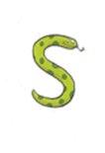 | 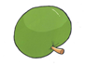 | 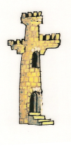 |  | 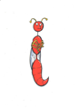 | 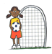
s | a | t | p | i | n
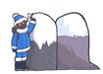 | 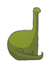
m | d | g | 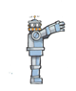  o | c | k
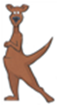 |  |  |  | 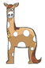 | 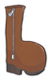
ck | e | u | r | h | b
Can you look at the letters and make the sounds?
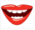
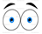

f | l | ff | ll | ss
Phase 2 letters and sounds

