***Investigating famous European classical composers…***

***Linked listening, composing and singing activities***

* **How does it make you feel?**
* **What does it make you think of?**

**Who might use this?**

**What purpose does it serve?**

**What would you change if this were for you?**

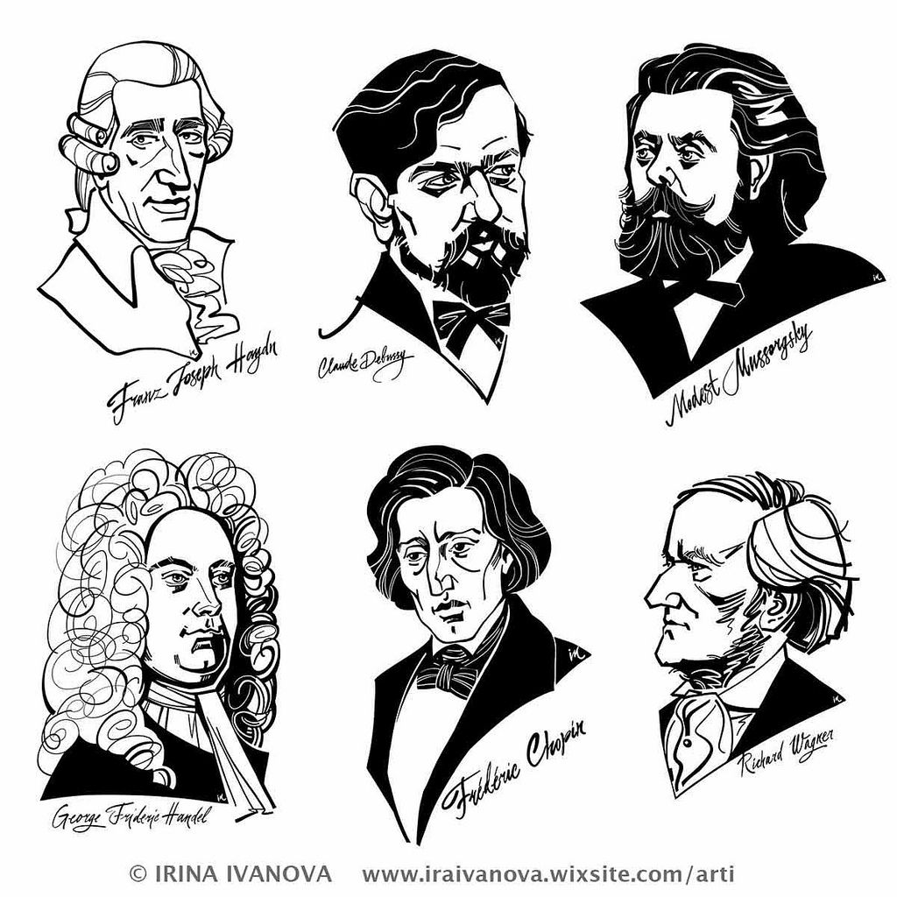

**Key vocabulary**

**Location Region Area Continent Country City Human Physical Landscape Topography**

**Globe Atlas Map Direction Compass Latitude Longitude Equator Northern Hemisphere.**

***Composer Composition Atmosphere***

***Product Style Purpose Design***

***Make Evaluate***

**Key questions**

* **What you know already about this region? What would you like to know or find out?**
* **Where is the region located? How far away is this region? How might people travel there?**
* **What is the physical geography like e.g. climate, landscape, rivers, mountains etc? What distinctive features does the region have?**
* **What is the human geography like e.g. settlement size, transport, tourist attractions, economic activity, and trade links?**
* **Why have towns and cities developed where they are?**
* **How does location, climate etc. have a bearing on economic activity in the region?**
* **What are the similarities and differences between this region and the region of the UK that has been explored previously in Year Three?**
* **What are the lives of children in this region like? How are their lives similar to ours? What would it be like to live in this place?**

DESIGN

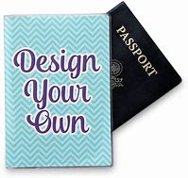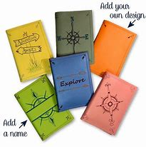

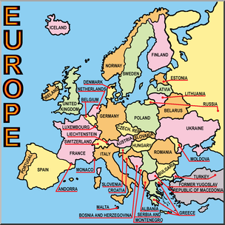

**Y4 Lent 2: Knowledge Organiser -**

***PASSPORT TO…***

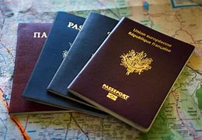

MUSIC