**Europe is the second smallest continent in size but the third largest in population. The European continent houses 50 countries.**

**Top Europe Facts**

**1. The European continent is located completely in the northern hemisphere and mainly in the eastern hemisphere. Europe borders onto the Arctic Ocean in the North, the Atlantic Ocean in the west and the Mediterranean Sea in the South.**

**2. There are 50 countries in Europe with a total of more than 748 million people living on the continent in 2021. However, of these 50 countries only 44 have their capital city on the European continent!**

**3. Largest country: The European part of Russia covers more area than any other country. The three largest countries are: Russia, the Ukraine and France.**

**4. Smallest country: Vatican City is the smallest country not only in Europe, but also in the world. The Pope lives here.**

**6. Biggest island: Great Britain/UK. Greenland is the largest island which belongs to Europe as the island belongs to Denmark. Greenland is commonly referred to as the largest island in the world.**

**7. Smallest town: Hum in Croatia is the smallest town not only in Europe but in the world. The town has only 30 inhabitants.**

**8. Most populous city: Istanbul, the biggest city in Turkey is commonly referred to as Europe's largest city. Istanbul houses about 17 million people.**

**9. Europe is the continent with biggest number of people per square kilometre or square mile.**

**10. Highest mountain: Mount Elbrus in Russia (5,642 m) in the Caucasus mountain range. The highest peak in the European Alps is Mont** **Blanc - 4,810 m high**

**15. Longest river: The Volga River in Russia. It is 3,692 km long. The largest waterfalls are The Rhine Falls in Switzerland.**

**17. Largest port: The port of Rotterdam in the Netherlands is the largest and busiest container port in Europe. Norway has the longest coastline in Europe - 100,000 km; the second longest in the world.**

**12. Northernmost capital city**: Reykjavík in Iceland is Europe's and the world's most northern capital city. [Read more about Iceland here.](https://www.kids-world-travel-guide.com/iceland-facts.html)

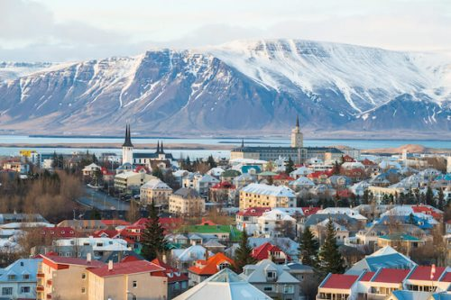***Reykjavík/Iceland***

**13.** **Largest landlocked country:**Kazakhstan is the largest landlocked country in Europe and in the world. 18 million people live in Kazakhstan which is among the ten biggest countries in the world.

Landlocked countries in Europe: Many countries in Europe, mainly in central Europe, do not have access to an Ocean and share national borders only with other countries. These are landlocked countries in Europe:

Andorra, Armenia, Austria, Belarus, Switzerland, Czech Republic, Hungary, Kazakhstan, Kosovo, Bosnia-Herzegovina, Liechtenstein, Luxemburg, Slovakia, Serbia, Moldova, Macedonia, San Marino and Vatican City.

San Marino and Vatican City are landlocked inside Italy, and Liechtenstein is double landlocked as it is landlocked also by countries Austria and Switzerland that are also landlocked by other countries.

**14. Highest mountain:**Mount Elbrus in Russia (5,642 m/ 18,510 ft) is the highest mountain in Europe. The mountain is part of the Caucasus mountain range.

The highest peak in the European Alps is Mont Blanc. The mountain which is 4,810 m/ 15,781 ft high sits on the border of Italy and France. The Alps are also the longest and highest mountain range that is located entirely in Europe!

**15. Longest river**: The Volga River in Russia is Europe's longest river. It is 3,692 km/ 2,295 miles long.

**16. Most important commercial waterway:** Danube. The river that flows through ten countries is the second longest river in Europe with 2,860 km/ 1,777 miles.

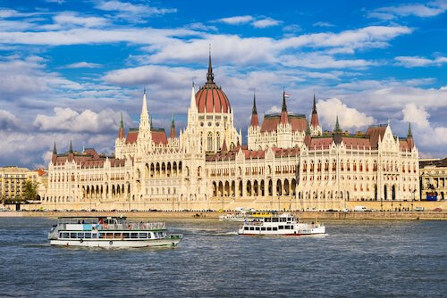***Budapest/Hungary***

**17. Largest port:** The port of Rotterdam in the Netherlands is the largest and busiest container port in Europe.

**18.** **Longest Coastline**: Norway has the longest coastline in Europe with over 100,000 km/ 62,000 miles; and it is the second longest in the world. [Read more about Norway.](https://www.kids-world-travel-guide.com/norway-facts.html)

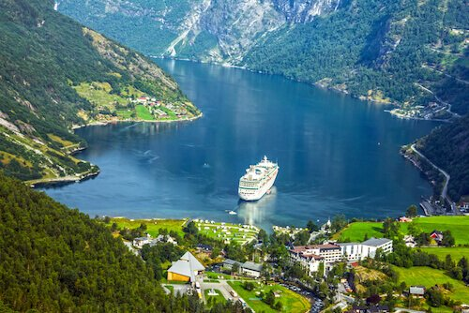***Norway***

**19. Biggest Lake**: Lake Ladoga near Saint Petersburg in Russia is Europe's biggest lake and one of the world's largest freshwater lakes. The lake is slightly smaller than Lake Ontario, which borders the USA and Canada.

**20. Largest waterfalls**: The Rhine Falls in Switzerland is the largest plain waterfall in Europe. They are 150 m/ 492 ft wide and 23 m/ 75 ft high.

**More Facts about Europe**

**Europe Facts | People**: About 10% of the world's population lives in Europe. In Russia, about 78% of the population, that is more than 110 million people live in the European part of the the world's largest country. Most of the European population groups, almost 90%, belong to one of the three Indo-European language groups of the Slavic, Romance and Germanic language groups.

According to the World Happiness Report from 2018 - 2020, the World's happiest people live in Finland - and they won for the last three years in a row!

**Europe Facts | Languages**: Most European languages belong to either the Romance languages (such as French, Italian, Spanish), the Germanic languages (among them are German, English) or the Slavic languages (among them Russian, Bulgarian, Polish). Russian is the language with most native speakers (about 100 million), while English as the '*lingua franca*' is the language spoken by most people as first and second language (about 270 million people). The five most spoken native languages in Europe are Russian, German, French English, Turkish and Italian.

**Europe Facts | Religion**: Most of the European people are Christians (76%) and there are smaller numbers of Muslims (6%) and Jews and other beliefs. About 18% of all Europeans consider themselves as atheist or not religious.

**Europe Facts | Animals:** In Europe, there are 270 species of mammals, such as boar, bat, deer, hare and otter. Of all mammal species 15% are endangered among them the wolf, bear and the lynx. There are 75 species of amphibians in Europe, most of them are endemic species in Southern Europe such as newts and salamanders. Slightly more than half of the 800 European bird species breed in Europe, all others migrate to warmer regions during the cold winter months.

**Europe Facts | Natural resources:** Metals such as zinc and silver and minerals such as copper, iron ore and coal are found in Europe. Some areas in northern Europe have deposits of natural gas and oil. Common agricultural produce that are farmed in Europe are wheat, potatoes, olives, grapes, oranges.

**Europe Facts | Agriculture**: About 39% of the land area in Europe is grassland or used for growing crops. The most common crops are cereals such as wheat, maize and barley as well as sugar beets, potatoes, vegetables and fruits and wine. France is Europe's biggest producer of agricultural products.

**Europe Facts | History:** The first humans appeared on the continent about 35,000 BC. The Minoan civilisation in the Bronze Age is seen as the first culture establishing trade and 'technology' from 2700BC. Among the many ethnic groups of the continent, the Greek tribes and the Germanic and the Italic people (later also the Roman Empire) had vast influences on the whole region as had the Celts. Later during the Middle Ages, the population increased due to the Vikings, Mongols, Huns, Magyars, Tartars and many other peoples that arrived and settled in the area. Europe's modern history is largely influenced by wars, such as the 30-Year-War (1618-1648), the French Revolution (1789) and the two World Wars in the 20th century. During World War I (1914-1918) more than 8 million people lost their lives and in World War II (1939-1945) over 18 million people died on the battlefields, during bombardment of the towns and cities and in Nazi concentration camps. In 1993, the European Union was established which today includes 28 countries.

**Europe Facts | Landmarks**: Five out of the top ten tourist destinations in the world are located in Europe. France is the number 1 tourist destination in the world with about 90 million international tourist arrivals per year.

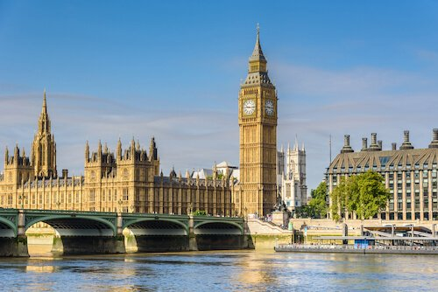***Big Ben and Houses of Parliament***

Among the most visited tourist sites and landmarks in Europe are:

[[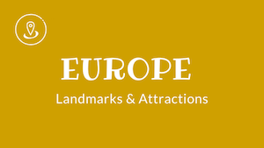](https://www.kids-world-travel-guide.com/landmarks-in-europe.html)***landmarks in europe***](https://www.kids-world-travel-guide.com/landmarks-in-europe.html)

* Tower of London in the UK
* Eiffel Tower in [France](https://www.kids-world-travel-guide.com/france-attractions.html)
* Neuschwanstein Castle in [Germany](https://www.kids-world-travel-guide.com/castles-in-germany.html)
* Alhambra in Spain
* Kremlin in Russia
* Acropolis in Greece
* Foro Romano in Italy

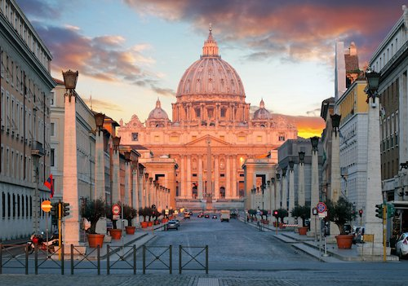

About 39% of the land area in Europe is grassland or used for growing crops. The most common crops are cereals such as wheat, maize and barley as well as sugar beets, potatoes, vegetables and fruits and wine.

Among the most visited tourist sites and landmarks in Europe are:

* Tower of London in the UK
* Eiffel Tower in [France](https://www.kids-world-travel-guide.com/france-attractions.html)
* Neuschwanstein Castle in [Germany](https://www.kids-world-travel-guide.com/castles-in-germany.html)
* Alhambra in Spain
* Kremlin in Russia
* Acropolis in Greece
* Foro Romano in Italy

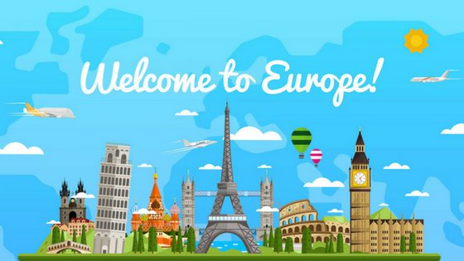

**Y4 Lent 2: Knowledge Organiser**