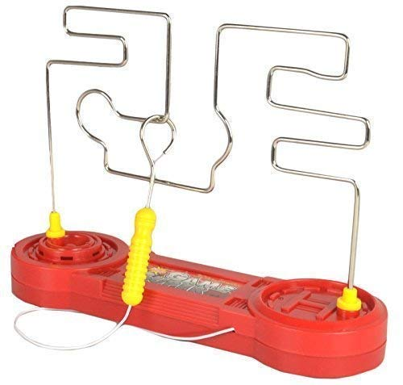



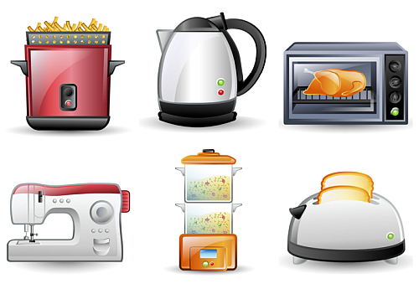

***SPARKS MIGHT FLY* Y4 TOPIC (1) KNOWLEDGE ORGANISER**

**Links**

**Music**

* **Use IT to Compose a short electronic composition for a specific purpose.**

**Design & Technology**

**Quiz board using a light or buzzer**

* **Evaluation of Existing Products**
* **Design & Make**
* **Share & Evaluate**

**Key Vocabulary**

**electricity The flow of an electric current or charge through a material, e.g. from a power source through wires to an appliance.**

**generate To make or produce.**

**renewable A source of electricity that will not run out. These include solar, nuclear, geothermal, hydro and wind.**

**non-renewable This source of energy will eventually run out and so will no longer be able to be used to make electricity. These include fossil fuels – coal, oil and natural gas.**

**appliances A piece of equipment or device designed to perform a particular job, such as a washing machine or mobile phone.**

**battery A device that stores electrical energy as a chemical.**

**circuit A pathway that electricity can flow around. It includes wires and a power supply and may include bulbs, switches or buzzers.**

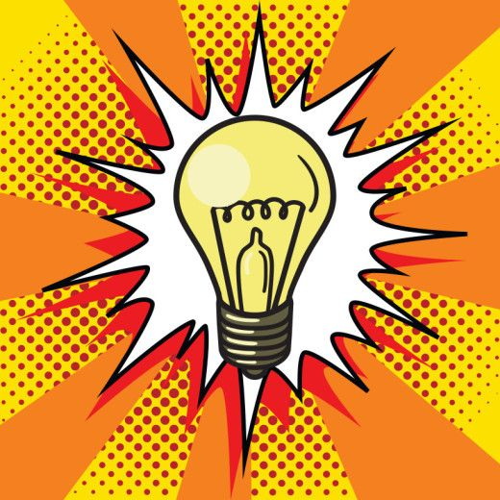

**Learning**

* **Identify common appliances that run on electricity.**
* **Construct a simple series electrical circuit, identifying and naming its basic parts, including cells, wires, bulbs, switches and buzzers.**
* **Identify complete cicuits**
* **Recognise that a switch opens and closes a circuit and link this with whether or not a lamp lights in a simple series circuit.**
* **Recognise some common conductors and insulators, and understand that metals are good conductors.**
* **Know that electricity can be dangerous.**
* **Recognise electricity sources can be mains or battery.**
* **Know that batteries ‘push’ electricity round a circuit and can make bulbs, buzzers and motors work.**
* **Recognise that faults in circuits can be found by testing connections.**
* **Know that drawings, photographs and diagrams can be used to represent circuits symbols**

