**D&T - *Key Qs:***

* **What are the essential elements of the eatwell plate?**
* **Which of these might be found on a desert island? Which could you grow?**
* **How might you secure protein e.g. meat or fish?**
* **What do these different fruits/root vegetables taste like? Smell like? Look like?**
* **What is their texture? Could we alter the texture by preparing the food differently?**

**Year 4 Knowledge Organiser: HUNTED**

**ART:** animal groups such as minibeasts, fish, reptiles, birds and other animals.



**Key questions**

* How can we describe sounds?
* What is the difference between sound and noise?
* How do we hear sounds?
* What happens to a sound the further we get from the source?
* How are sounds created?
* How do sounds travel?
* How can sounds be changed?
* How can we block or muffle sounds?
* What if there were no sounds?
* What if we didn’t have ears?
* What if all sounds were noisy or all sounds were quiet?

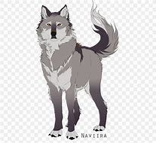

*Science (2) – Sound:*

**Key vocabulary**

* Sound, source, quiet, soft, noise, vibrate, vibration, travel, loudness, volume, loud/quiet, faint / fainter, pitch, high/low, muffle, tuning, tension, tight, air, air column, instrument (strings, brass, woodwind, percussion).

**Hunted – debate, narrative & folk tales on the theme**

**vocabulary**

* Words related to: life processes - nutrition, habitats, feeding.
* Relationships: environment, habitat, condition, organism, carnivore, herbivore, omnivore, predator, prey, producer, consumer, food chain, key, classify, classification key, positive human impact, negative human impact.
* Words which have a different meaning in other contexts: producer, consumer, key, condition.
* Vertebrates and invertebrates: insects, minibeasts, mammals, reptiles, fish, birds, amphibians.

**Science – *Key Qs:***

* **What can we find today?**
* **What is a minibeast / bug?**
* **How are animals / plants adapted or suited to live in our school grounds / local area?**
* **Why does it like it there?**
* **What does it eat?**
* **Does anything eat it?**
* **How many different living things are there in the world?**
* **What makes an animal an animal?**
* **Are they all the same?**
* **How are animals different?**
* **How many different animals are there?**
* **How do scientists group them/identify them?**
* **Why are some species under threat while others are not?**
* **What happens if we remove a species from the food chain?**
* **What threats are there to different habitats / ecosystems?**
* **How can humans help?**

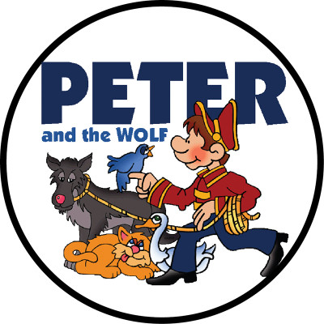

**ART: animal groups such as minibeasts, fish, reptiles, birds and other animals.**

