**Key Vocabulary**

**Pyramid - monumental structure built of stone as a royal tomb in ancient Egypt.**

**Tomb - large vault, typically underground, for burying the dead.**

**Pharaoh - ruler in ancient Egypt**

**Hieroglyphs - picture of an object representing a word, syllable, or sound.**

**Papyrus - material prepared in ancient Egypt from the stem of a water plant, used in sheets for writing or painting on.**

**Rosetta Stone - stone slab found near Rosetta, Egypt, in 1799. It is carved with Greek & hieroglyphic inscriptions so scholars could work out the Egyptian writing**

**Shaduf - hand-operated device for lifting water**

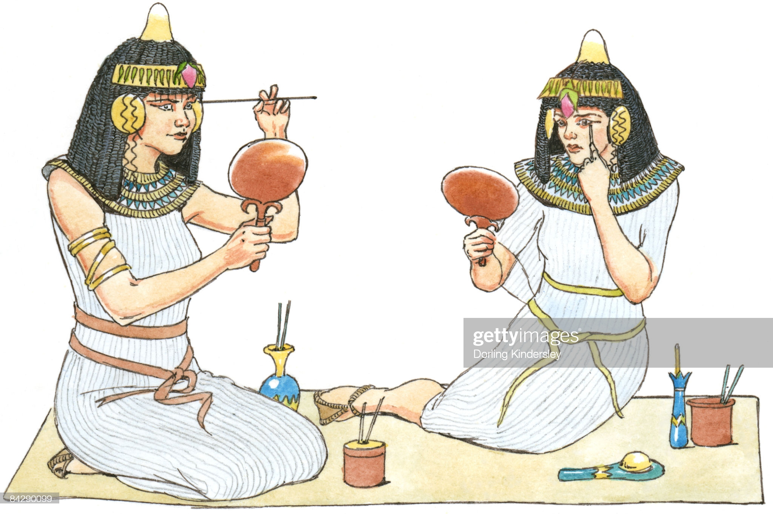

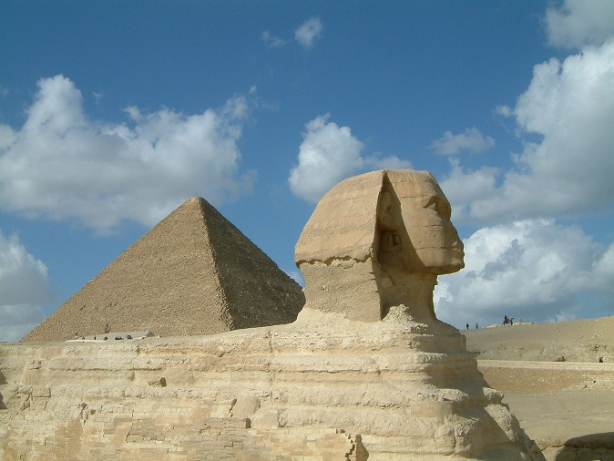

**Fun Facts**

**Ancient Egypt was one of the most powerful civilisations.**

**It started in 3150BC until 30 BC – so it lasted for around 3000 years!**

**It was based along the River Nile.**

## Pyramids and tombs were used for Pharaohs.

## Egyptian men and women wore make up

## They used hieroglyphs to write

## There were over 2,000 ancient Egyptian Gods and Goddesses.

**WATER, WATER, EVERYWHERE**

**Ancient Egypt / The River Nile**

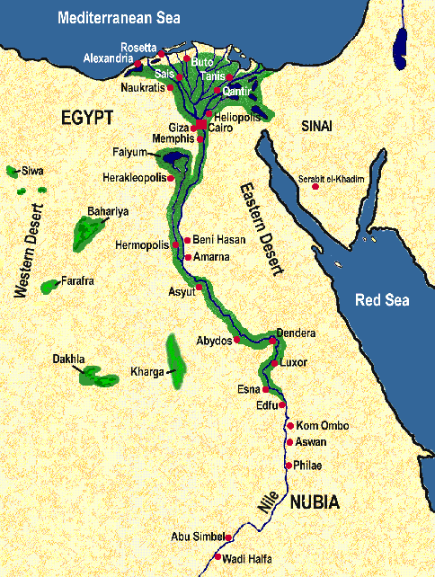 **Key Learning…**

**Ancient civilisations and their way of life - Indus Valley, The Shang Dynasty, Ancient Sumer, Ancient Egyptians**

**Locating Egypt and the River Nile?**

**The Ancient Egyptians use of the River Nile**

**Ruling Ancient Egypt / the pharaohs?**

**Life for different people and groups of people**

**Egyptians after they died - pyramids and how they were built**

**How we know about ancient Egypt and the achievements of the Ancient Egyptians**

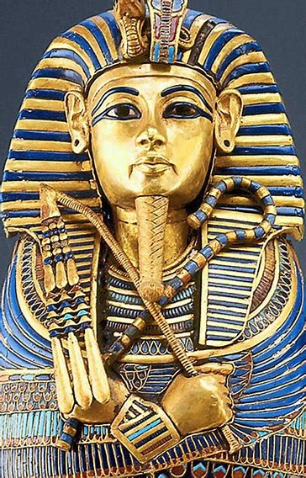 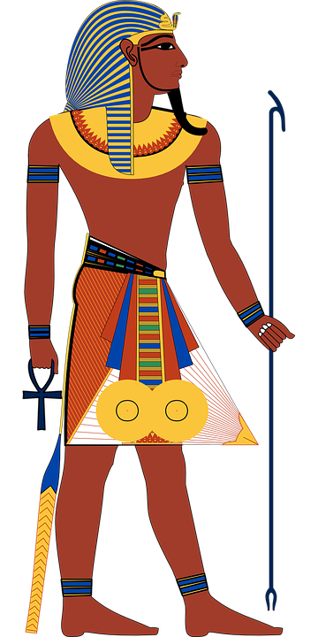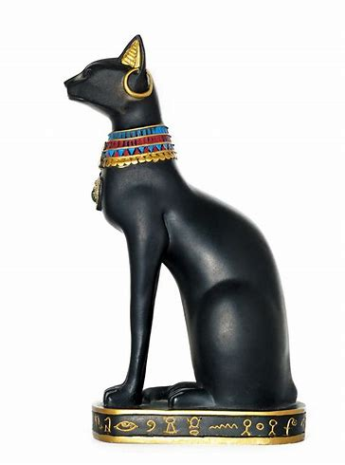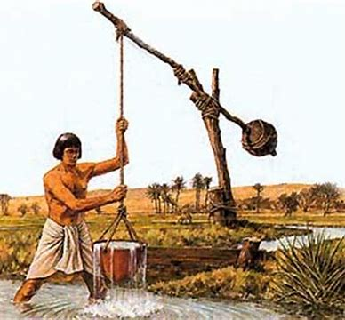****

**Y4 Pentecost 1: History Knowledge Organiser**