**Skull!**

SOS

Caring for the Environment

The Great Plague

**Investigate different grades of pencils, charcoal and chalk to make careful drawings.**

**Translated, repeat, rotate images**

**Jean Basquait & Escher’s ‘Eye with Skull’**

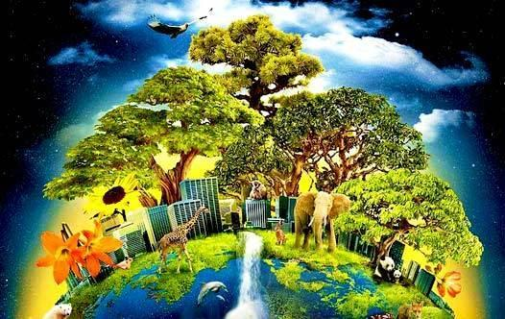

**Knowledge Organiser: History / Geography / Art & Design Topic**

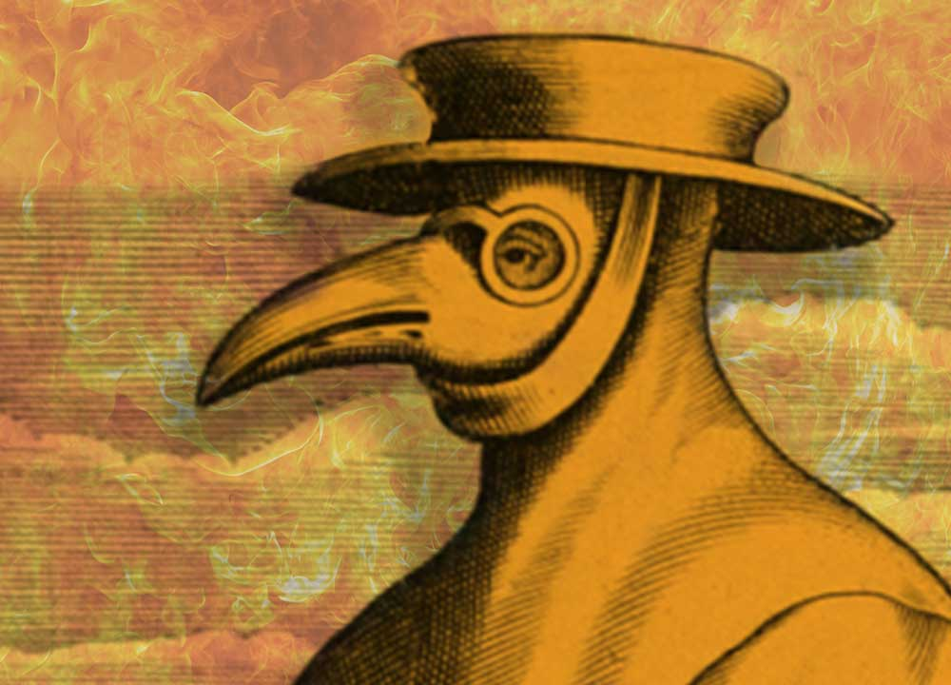 ****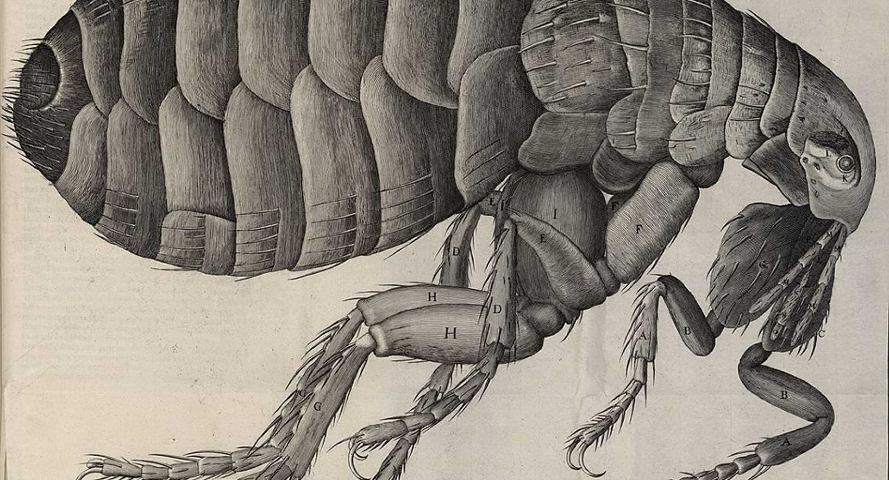

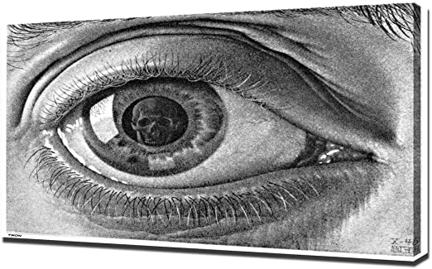 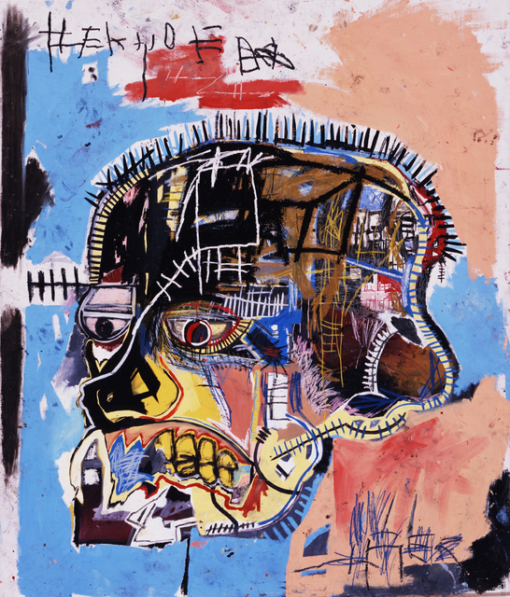 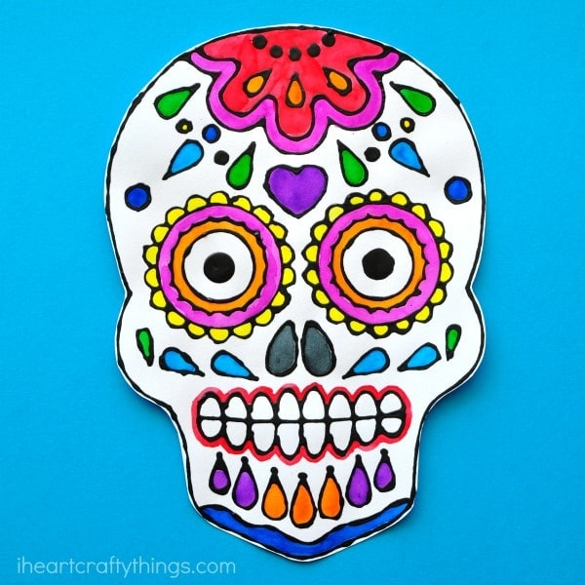 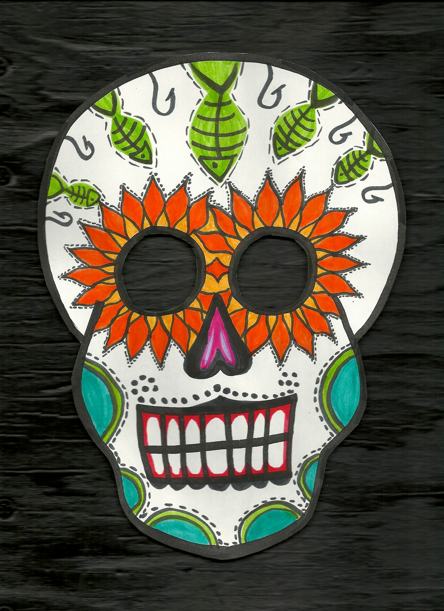



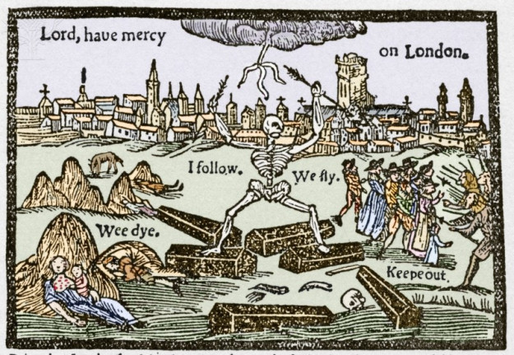

**Art & Design**

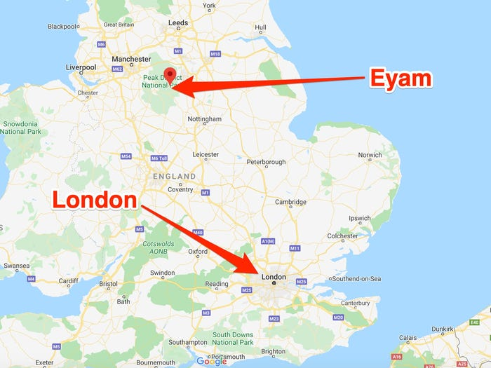

**Locating Eyam and London on maps**

**Environmental cleanliness**

**Landfill**

**Recycle & reuse**

**Local waste recovery facilities**

**Waste produced nationally and globally**

**Industries/countries are working to reduce different types of waste**

**Geography**

**History**