**Art & Design: Cezanne, Renoir,** [Tjalf Sparnaay](https://www.google.com/search?q=Tjalf+Sparnay&aq=f&oq=Tjalf+Sparnay&aqs=chrome.0.57j0l3j62.1141&sourceid=chrome&ie=UTF-8)

* **observational studies of food and fruit displayed in a still life**
* **drawing opportunities in sketchbooks**
* **paintings**
* **3-D sculptures**

**Music – for setting….**

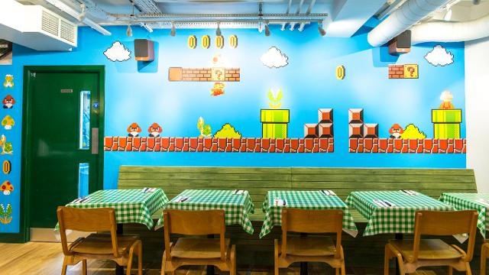



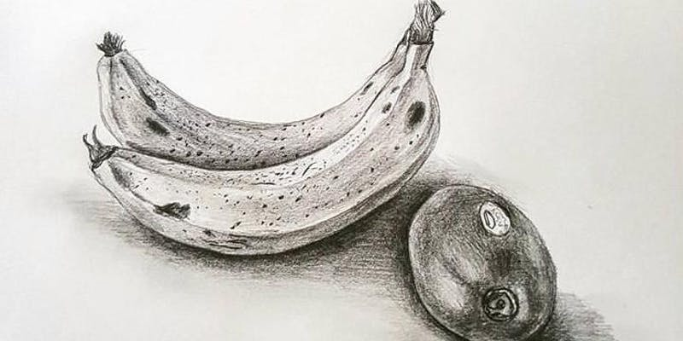

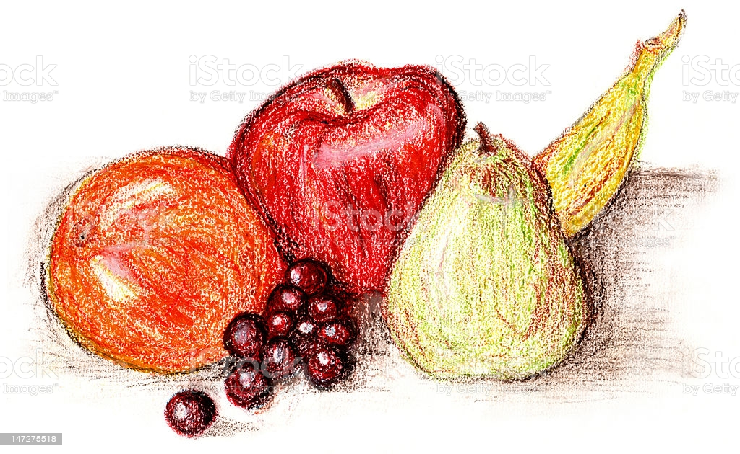

**Key questions**

* **Why do we have teeth?**
* **What do the teeth do?**
* **How many teeth do we have? Is it the same for everyone?**
* **Why do we lose teeth?**
* **How can we care for our teeth and gums?**
* **What are the teeth like of other animals?**
* **How does this give us information about what they eat?**
* **How are the teeth of carnivores and herbivores similar or different? Why?**
* **What happens to our food once it enters our mouths?**
* **What happens in our bodies between eating our food and going to the toilet?**

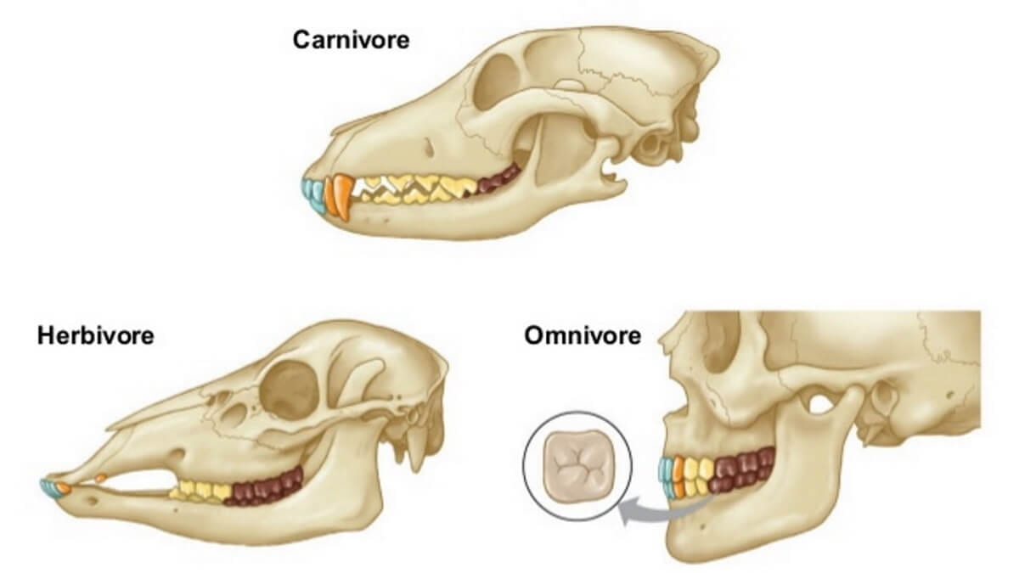

**Key vocabulary**

**Eat, chew, breakdown, saliva, swallow, feed, feeding, healthy, unhealthy, function, producer, predator, prey, dentist, toothpaste, dental care, hygienist, teeth, gums, incisor, molar, canine.**

**digestive system, mouth, tongue, oesophagus, stomach, small intestine, large intestine, faeces.**

**diet, root, activity, decay, evidence, conclusion.**

**digestive juices, churn, energy, nutrients, absorbed, blood, liver, bladder, anus.**

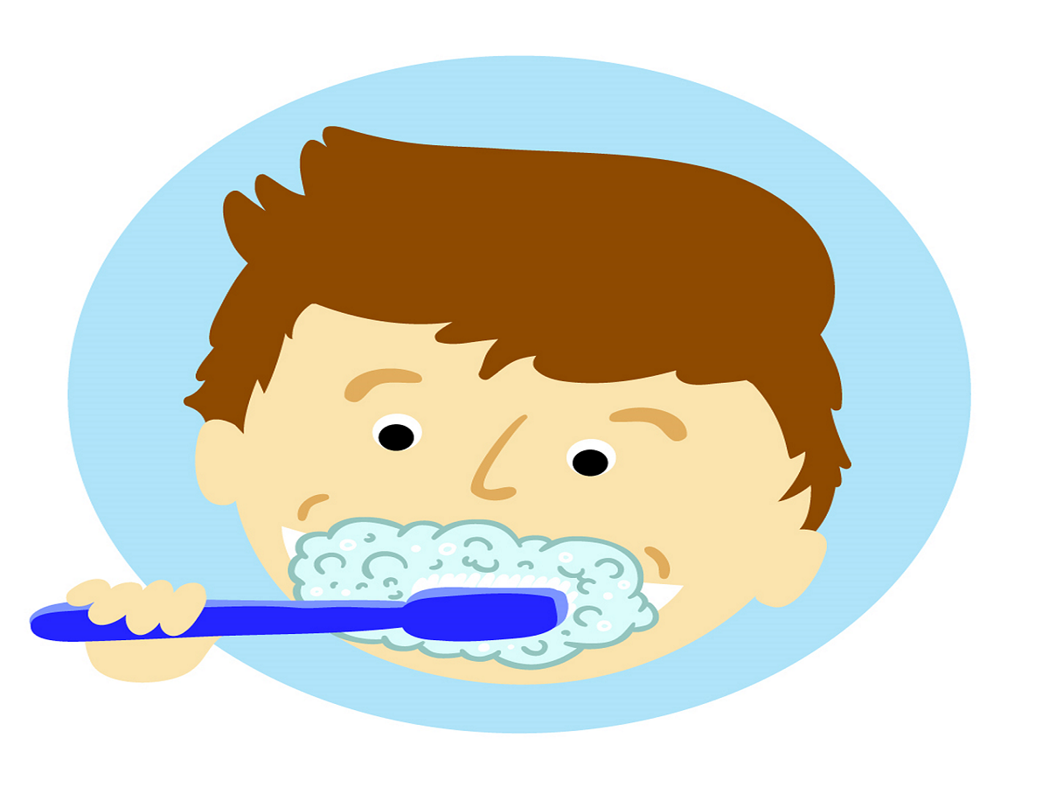 

**Animals – Teeth and Digestion**

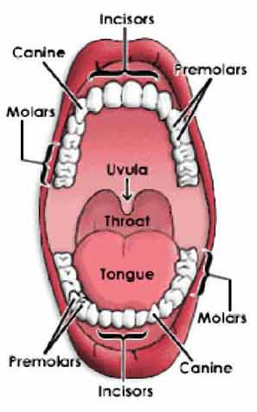

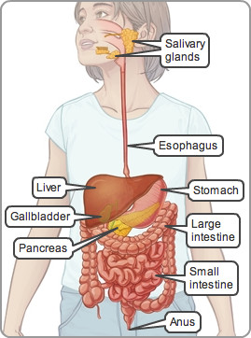

**Y4 Lent 1: Knowledge Organiser - The Art of Food**